Troop 229 By-Laws
Princeton, Texas

Parent Guide for New Scouts
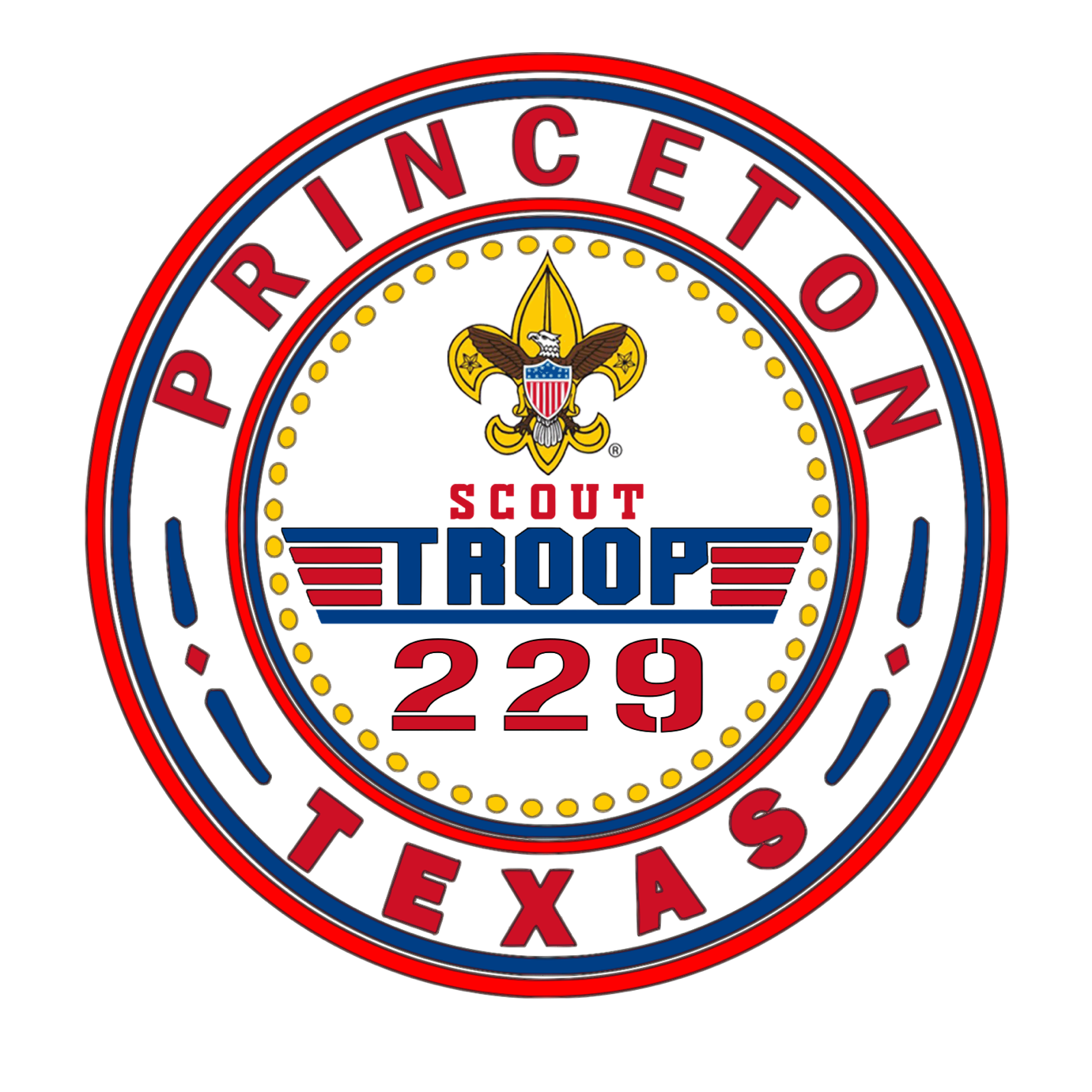

Circle Ten Council
Scouts BSA

TROOP 229 PURPOSE

Troop 229 and Scouts BSA exist to provide youth an effective program designed to build desirable qualities of character, to train in the responsibilities of participating citizenship.

Our program is about the development of your child’s physical, mental, and emotional health.

Troop 229 is a “youth-led” Troop, meaning that the activities and meetings are led by the Scouts themselves, under the guidance and supervision of registered BSA Adult Leaders. The Adult Leaders in the Troop provide the structure within which the Scouts plan and conduct their meetings, outings, service projects and special events.

Our vision for our Troop is to ensure the quality and survival of our Troop and our program based on the successful use of the Aims and Methods of Scouts BSA. How we achieve our vision is through the mission of our Troop. Focus the greatest amount of time, energy, and resources on the youth who buy in to the program. Buying in means the youth must commit to the youth-led program and invest the time needed in their own development. As a group we do not believe in doing for the youth, what we believe they are capable of learning to do for themselves. We can teach them, and we can coach them, but the full benefit of this program is realized when the youth is committed to their own development. We will take care to help each youth understand the benefits of this Scouting program and the expertise added through our adult volunteers, but in the end the scout must choose, on their own, to make the level of this commitment for their own development. In order for us to achieve the success we are striving for we need your help as parents to understand our program. For this reason, we have provided this guidebook as a resource. We have included some basic information you will need to help your child achieve the full benefits of Scouting. There are numerous resources provided by Scouts BSA that guides our work and if you are interested, we can make them available for your use. If you were a Scout, please understand there have been numerous changes over the years to keep the program current with the changing needs of our society. There have been major changes in safety, laws, and camping procedures to name a few. So, you might be surprised to find we may not do some of the things you did as a Scout. Regardless of your experience with Scouting, we welcome you and hope that that you will take the time to explore with us and understand what we do as an organization to support your work as parents. Give scouting a chance, the benefits are worth it!

Purpose and Scope of By-Laws

These By-Laws establish the policies and procedures of Troop 229, subject to the higher policies of the Scouts BSA rules and guidelines. In the event that any guideline set forth in this document contradicts a guideline set forth in any official Scouts BSA publication, the Scouts BSA publication will always take precedence. Any contradiction should be reported to both the Scoutmaster and the Troop Committee Chairman. The policies and procedures contained in these By-Laws apply to all members of Troop 229 and to all authorized guests of members of the Troop, when engaged in any sanctioned troop activity. The Troop Committee is responsible for the content of these By-Laws and for all future amendments and modifications to the By-Laws, if any. Recommendations for changes or additions to this document should be made in writing to the Troop Committee Secretary for consideration by the Troop Committee.

TROOP 229 ACTIVITIES

To fully participate in Troop 229’s program, your new scout will want to attend:

Troop and Patrol Meetings

Regular meetings shall be held weekly.

Courts of Honor, held to recognize the youth who have earned advancement in rank, merit badges, etc., are held throughout the year at a designated location determined by the committee.

A meeting schedule, which indicates all our activities, is published at the beginning of the year and updated as needed throughout the year. Monthly activity updates are published on the Troop website.

Detailed information can be found by logging into Scoutbook.

Monthly Camping Trips

Camping trips are planned monthly. Also, pre-campout patrol meetings are held during troop meetings to help in planning activities for an outing.

Due to Scouts BSA insurance requirements, unless a campout or activity is specifically designated as a “Family” campout or activity, only registered Scouters and Scouts may participate in the camp or activity. Exceptions to this rule may be requested from the Scoutmaster no later than two weeks prior to the campout or activity. Granting such an exception shall be at the discretion of the Scoutmaster.

The Scoutmaster will establish an assembly place and time, and a departure time for traveling to the campout or activity, to provide for enough time to prepare the troop and its equipment. The troop will depart at the designated time, and any stragglers will be expected to find their own way to the camp or activity site.

Day Activities (no camping)

Hikes, lock-ins, rock climbing, or service projects, etc. may take the place of a camping trip depending on weather and participation.

Quarterly Parent Meeting

Every quarter a parents meeting shall be held to address upcoming activities and events for the next quarter, address any concerns, hear any ideas for improvements and will also hold the Court of Honors.

Summer Camp

The troop shall attend a week-long summer camp each year. This provides an excellent way for new scouts to bond with the older scouts, earn merit badges, and have fun!!!

High adventure trips shall be planned annually if possible. These can be, but are not limited to, any combination of hiking trips, mountain climbing, or other activities offering the scouts an exceptional opportunity to become self-sufficient in accordance with all BSA regulations. These trips are for experienced Scouts age 14 and over and everyone attending must have a BSA Medical A, B & C on file.
Additional information is available throughout the Scout year.

Training Program

All new scouts will be given opportunities at Troop meetings and outings to learn skills and ideals to enable successful camping and life experiences. The campouts will begin the Scout on their advancement program to become an Eagle Scout.
The Scoutmaster and Assistant Scoutmasters will work with the scouts to guide them through rank advancement. Work on rank advancement shall be done during outings and at troop meetings.

TROOP ORGANIZATION

The Troop will be composed of one Senior Patrol Leader (“SPL”), one to four Assistant Senior Patrol Leaders (“ASPL’s”), and one or more patrols, each with a Patrol Leader (“PL”).

Senior Patrol Leader

The Senior Patrol Leader is elected to their position up to twice a year, as determined by the Scoutmaster and the Troop Committee, by members of the troop present at the meeting during which the election is held, after at least a one-week notice of the forthcoming election. Included in this election notice will be a list of those scouts who have met the criteria for SPL. Candidates for the position of SPL and ASPL must be at least First-Class rank and are subject to the approval of the Scoutmaster. No Scout can hold the position of SPL for two consecutive terms without Scoutmaster approval. A new SPL takes their post on the first day of the month following their election. In order to be an SPL, a Scout must be at least 13 years of age, First-class rank, have previously served as a Patrol Leader, Troop Guide, or ASPL, and have been an active member of the Troop for the previous six months. Oak Leaf and National Youth Leadership Training is preferred but not required.

Assistant Senior Patrol Leader

The Senior Patrol Leader may appoint up to four Assistant Senior Patrol Leaders. Like the SPL, ASPL’s are subject to Scoutmaster Approval.

Scoutmaster-Appointed Positions

Troop Guides, Troop Instructors, Den Chiefs and the Order of the Arrow Representative will be appointed by the Scoutmaster.

SPL Appointed Positions

Other BSA Troop level positions of responsibility such as Scribe, Bugler, and Quartermaster will be appointed by the SPL after approval by the Scoutmaster.

Patrols

As described in the Scouts BSA Handbook, each patrol should contain no fewer than five Scouts in order to efficiently use troop camping equipment. All Scouts will be members of a patrol, except for the SPL and any ASPL’s when acting in that capacity.

Patrol Leaders

Patrol Leaders shall be elected to their positions ordinarily coinciding with election of the SPL, by members of their patrol present at the meeting during which the election is held. Candidates for the position of Patrol Leader must be at least 2nd Class rank (except in the case of first-year patrols) and are subject to the approval of the Scoutmaster. To be a Patrol leader for a first year patrol a Scout must be at least Tenderfoot rank and be no younger than 11. No Scout can hold the position of Patrol Leader for two consecutive terms without Scoutmaster Approval, which can only be granted when there are no other qualified Scouts wanting to stand for the Patrol Leader election. The new Patrol Leader will assume their role on the first day of the month following their election.

Other Patrol Officers

Each Patrol Leader shall appoint an Assistant Patrol Leader, subject to the approval of the Scoutmaster, and can fill other positions of responsibility in their patrol from members of their patrol in any manner they choose, with Scoutmaster approval.

Patrol Leaders Council

The Patrol Leaders’ Council (“PLC”) is the planning and decision-making team within the troop made up of Scout leaders. The PLC, with guidance from the Scoutmaster and their adult assistants, shall lead the Troop in accordance with the guidelines in the BSA Scoutmaster Handbook.

PLC Administration

As the top Scout leader in the troop, the Senior Patrol Leader, with the advice of the Scoutmaster, leads the PLC and chairs its meetings. Besides the Senior Patrol Leader, other voting members of the PLC include Assistant Senior Patrol Leaders, Patrol Leaders and Troop Guides. Each Patrol is represented by its Patrol Leader on the PLC. Although they have no vote, the Troop Scribe attends PLC meetings to keep a log of each meeting. Other Scouts in positions of responsibility may be invited to PLC meetings on an as needed basis.

TROOP 229 POLICIES

Eligibility

Membership in the Troop is available to youth who have completed the fifth grade or earned the Arrow of Light Award and is at least 10 years old, but is not yet 18 years old.

Transfers from Other Scouts BSA Troops

If a scout is transferring into the Troop from another Scouts BSA troop, the transfer is noted on the registration form, and advancement records, signed by the previous troop’s advancement chairman, are required to be provided. These records must include the dates for all rank advancements, merit badges, leadership positions, service hours, and other awards or honors.

Active Membership

In order to be judged an active member, the Scout must have attended 60% of the Troop campouts and Troop meetings over the course of the past year. Absences due to attendance at other Scouts BSA events or excused by the Scoutmaster will be counted as attendance. The Scoutmaster may waive this requirement for good cause.

Application

Youth apply to the Troop by completing an official application with their parents and submitting the application to the Scoutmaster. A youth becomes a member of the Troop when they have paid the required fees and their application is approved by the Scoutmaster and the Troop Committee.

Prospective Members

Any youth, particularly Webelos Cub Scouts, interested in joining the Troop are encouraged to attend Troop meetings or other Troop activities. The youth’s parent or den leader must accompany the youth and must obtain the Scoutmaster’s permission to attend the event. The youth must pay any necessary fees for activities that they attend. Prospective members are not covered by the Troop’s insurance.

Scoutmaster and Assistant Scoutmaster

The Scoutmaster is the adult leader responsible for the image and program of the Troop. The Scoutmaster and Assistant Scoutmasters are appointed by the Troop Committee with approval from the head of the chartering organization. The Scoutmaster shall serve for a term of no longer than five years and may not succeed their self. The Scoutmaster and their Assistant Scoutmasters work directly with Scouts in implementing the troop program pursuant to Scouts BSA guidelines.

Troop Committee

The Troop Committee shall function in accordance with the National Committee Guidelines of Scouts BSA and is comprised of a group of adult leaders charged with the duty to support the Scouting program and handle troop administration.

Committee Positions

Troop Committee positions shall include the Committee Chair, Secretary, Treasurer, Outdoor/Activities Coordinator, Advancement Chair, Chaplain, Training Coordinator, Equipment Coordinator (Quartermaster), Fundraising Chair, and Membership Coordinator. Duties of each position are as described in the BSA Troop Committee Guidebook. Other positions may be included as needed. One person may hold up to two positions.

Troop Committee Terms

The terms of all Troop Committee positions shall be one year, and individuals may succeed themselves.

Troop Committee Elections

Elections shall be held annually in conjunction with the Troop re-charter for all terms completed or unfilled positions. The election slate will be established by a sub-committee proposed by the Committee Chairperson and approved by the Committee. The sub-committee shall present the slate to the Committee, which shall open the floor to nominations. If any nominations are made, the additional name(s) shall be added to the election slate. Once nominations are closed, the committee shall then vote on each position. All committee members are allowed one vote. Each individual must be present to cast a vote unless extenuating circumstances exist. When extenuating circumstances apply, the Committee may approve use of absentee ballot(s) by majority vote. The vote shall be by secret ballot unless there is only one person slated for the position. A voice confirmation vote is all that is required when there is only one person on the slate for a position. The Committee Chair shall reserve their vote for tie breaking. A majority vote is required. If there are more than two individuals running for a position, and no individual receives a majority, the person receiving the least number of votes will be eliminated and a second vote will be taken to select between the remaining individuals. The process will be repeated until an individual receives a majority vote. If the two lowest individuals on any vote receive the same number of votes, the tie shall be broken by the Committee Chair. New Committee leaders will take office on the first day of the month following the vote, unless circumstances require an earlier change of selected positions. If any officer cannot serve their full term, the Committee Chair will select an individual to complete the term. The replacement officer must be approved by a majority vote or voice approval of the Committee.

MEETINGS

Troop Committee Meetings

The Troop Committee shall meet monthly at such times and places as may be established by the Committee Chair, giving due regard to the desires of the members of the Troop Committee. The Committee Chair or Secretary will notify all members of the Troop of meetings within one week of the date of each such meeting, shall publish and provide an agenda for each meeting, and may call other committee meetings as necessary. Troop Committee meetings are open to all parents and registered Scouters, but only registered adult leaders serving on the Troop Committee may vote on matters affecting the Troop. All matters brought before the Committee, excepting disciplinary matters and amendments to these Bylaws, shall be decided by a majority vote of the Committee members present.

Quorum for Committee Meetings

A quorum for committee meetings shall be defined as attendance by three (3) Committee positions plus two (2) other Committee members, for a total of five (5) voting attendees. Attendance may be by written proxy.

General Troop Meetings

Troop meetings will begin promptly at the time and meeting place designated by the troop committee. A regular schedule of weekly troop meetings shall be determined at the annual planning conference and published. Troop meeting plans are the responsibility of the Senior Patrol Leader and the PLC.

Patrol Leaders Council Meetings

Patrol Leaders Council meetings shall be held at least once a month. The purpose of the monthly PLC meetings, in general, is to detail plans for the regular troop meetings and for any troop campout or other troop activities scheduled in the coming month.

Extra PLC Meetings

Additional PLC meetings can be called by the Senior Patrol Leader for planning purposes. Such meetings must be announced in advance so that participants can make the necessary arrangements. These meetings, when called, require adult Scouter support.

Troop Dues

The committee shall establish yearly Troop dues. This fee shall be due by the last day of September of each year or when any new scouts join the troop. The fee, along with fund raisers, covers most of the normal costs (merit badges, fees, Court of Honors and other troop expenses) associated with running the troop for the year.

The Boys Life magazine and BSA yearly membership dues are included in the yearly troop dues. The BSA membership fee and Boys Life subscriptions are paid by the troop every year when charter renewal is completed.
All adults who are associated with our troop must register as Adult Volunteers with BSA. Registered adults will also be required to complete Youth Protection Training (YPT) that is valid for 2 years from date of completion. The Scouts BSA membership fee for adult volunteers is paid through the general troop account and covers Scouts BSA insurance and an adult background check. Adult applications shall not be turned in to the BSA office until the adult volunteer provides proof of completion of the YPT course.
Scouts behind on dues will not be eligible to receive rank advancement and will not be allowed to attend monthly outings.

Exceptions and assistance are offered to scouts in need. Please contact the Scoutmaster or Committee Chairman to discuss options.

Costs for other activities (campouts, etc.) are separate from the dues and are payable by the participants.

Financial Assistance

Troop 229 is committed to providing the Scouting experience to any youth who wants to join, regardless of family financial situations. Any Scout or parent may request financial assistance by contacting the Scoutmaster or Troop Committee. Requests will be handled discreetly by the Scoutmaster and Troop Committee.

Attendance

Meetings:
A Scouts regular attendance at weekly troop meetings, monthly outings and the troop activities is necessary to fulfill advancement requirements toward the Scouts next rank.

Other Events:
Attendance at campouts, service projects, fund raisers, etc. will be considered in appraising the scout for “Be active in your Troop” and “Scout Spirit” requirements for advancement.

CODE OF CONDUCT:
Scouting is a safe environment, where any youth can feel comfortable trying new experiences. However, there are expectations on how a Scout should act both at meetings and outings. Bullying and or hazing by other scouts or scout adults will NOT be tolerated. Refer to the Code of Conduct for specific behavior expectations and consequences.

Adults that attend meetings shall conduct themselves according to Scouting standards and will be a positive impact on any adult or youth scouters they interact with. If at any time a parent or other adult becomes disrespectful, belligerent or otherwise breaks any of the Scouts BSA policies they will be asked to leave and come back when they can conduct themselves appropriately, a second offense will result in the offending adult to be banned from Troop activities.

PARENT AND THE NEW SCOUT

These are some of the things that will help your child get the most out of Scouting:

- Help your new scout learn to plan ahead; scout activities will have minimal conflict with schoolwork. We realize that schoolwork must come first.
- Help your new scout learn the scout skills and help the scout plan opportunities to master scout skills. The Troop leaders will sign a scout’s book when a skill is learned. See the BSA Handbook for details.
- Encouragement from you can be very helpful in making steady progress in advancement.
- Join your scout on Troop campouts. Parents are welcomed on campouts. You’ll be surprised! You can have a good time on outings too!
- Attend the Courts of Honor which are held throughout the year to honor the youth who have advanced in rank or earned merit badges.
- Serve our Troop as an adult leader. This can be as an Assistant Scoutmaster, committee member, or merit badge counselor. Please contact the Committee Chairman or Scoutmaster for more information.
- Support Troop fund raising programs. Each year, the Troop spends money for equipment, awards, campground fees, and adult and youth leadership training programs. We count on the Scout’s parents to support our fund-raising efforts.
- Provide your new scout with the basic scouting equipment needed for meetings and campouts.
- And most of all, support the ideals and purposes of scouting. In addition to providing fun activities for scouts, the purpose of scouting is to build character, citizenship, and physical and mental fitness. Your scout will get as much out of scouting as they put into it. Our experience and the National BSA experience show that they will derive much more from scouting if you, as parents, are involved in the program.

REQUIRED EQUIPMENT FOR THE NEW SCOUT

There are two “Must Have” items for the new scout:
- The OFFICIAL SCOUTS BSA HANDBOOK, latest edition.
- The OFFICIAL SCOUTS BSA CLASS A UNIFORM.

The uniform, as worn by the scouts of Troop 229 is required.

The scout will be considered out of uniform if they are not wearing the uniform properly, unless told otherwise by the Troop Scoutmaster.

Class A Uniform

Required:
- Long or short sleeve shirt, official BSA American Flag (right sleeve)
- Pair of green shoulder applets
- Council Patch (left sleeve)
- Emblems of office Troop 229 Patch (left sleeve)
- Rank patch, Patrol patch, Neckerchief and slide
Note: most scouts have the short sleeve shirt

Optional: (required for 1st class and above)
- Pants, long or short, official BSA
- Socks, green, official BSA
- Web belt and buckle, official BSA
See the Scout Handbook for exact placement of emblems.

Class B Uniform

Any scout related T-Shirt.

Except for the Troop 229 patch, all the above items are available at the store in the Scout office: Fairview Office at 5600 US Hwy 75, Fairview, TX, 75069, (972) 359-9992 or the Dallas Office at 8605 Harry Hines Blvd, Dallas, TX, 75235.

Rank emblems are presented at a Court of Honor ceremony by the Advancement Chairperson. The neckerchief slide may either be purchased, or handcrafted, as the scout desires.

If the scout has passed through the Webelos program, they may wear the Arrow of Light emblem and the religious knot. These are available through the Scout office.

Uniforms are required for all regular meetings and District Camporees. Uniforms are worn while traveling on Troop campouts and during flag ceremonies. Uniforms are required at summer camp, preferably short sleeve shirts.

BASIC CAMPING EQUIPMENT FOR THE NEW SCOUT

For an overnight campout and for summer camp the scout will need the following equipment (don’t buy anything until after your 1st troop meeting)

Backpack Mess kit / eating utensils
Liquid filled compass Canteen / Water bottle
Hiking boots Waterproof match case
Rain gear Sleeping Bag / Foam Pad
Personal first aid kit Pocket knife (need TOTIN’ CHIP)
Flashlight (with fresh batteries) Tent

Most other items are furnished by the Troop, such as:

Griddles Dining Fly
Water Jugs Plastic ground cloths
Dutch Ovens Cook Kits
Stoves Patrol Cook Boxes
Saw and Ax

The Troop also maintains a well-stocked first aid kit.

CAMPING EQUIPMENT NOT TO BUY … OR WHAT NOT TO BRING

- Sheath knives of any type are not allowed by the BSA. All knives must be lock-blade. Once a Scout completes their TOTIN’ CHIP, they can carry a knife.
- Axes of any type are not needed. The proper use of the ax is taught to all scouts by out troop leaders using troop axes.
- No liquid fuel warmers or any other devices which use liquid fuel are allowed.
- Candles or any other flame lights are not allowed in tents.
- No aerosol cans (insect repellents, deodorant, etc.). They can explode in campfires!
- No camouflage clothing (jackets, pants, etc.) is allowed. It makes it very difficult to find a lost or hurt scout in the woods.
- NO ELECTRONICS … Adult leaders only may have cell phones in case of an emergency or need to be contacted by a parent.

PARENT PARTICIPATION OPPORTUNITIES

Troop committee: The role of the troop committee is to support the Scoutmaster and the troop in an advisory capacity. The committee helps to generate ideas, manage finances, coordinate activities with the sponsoring organization, and provide logistical support, such as coordinating camping trips, special events, etc. for the troop’s scouting program.

Merit badge/skill award instructors: One of the purposes of scouting is to have the youth advance in rank by earning merit badges and completing skill requirements. Any parents with a skill who can advise the youth, organize the activity, or teach the skill can be an advisor. A merit badge counselor is registered with Scouts BSA and is available for counseling and approving the youth for earning the badge. Any adult can be a merit badge counselor. Having adults associated with our troop as counselors makes it easier for the youth to earn merit badges. There are many merit badges in just about every field. We always need more merit badge counselors.

Patrol advisors: The troop is organized into small groups called patrols. Activities on troop meeting nights and on special events revolve around the patrol. The patrol advisor will be an adult that the patrol leader can turn to for help in organizing activities, generating ideas, etc.

Special Events Coordinator: There are many kinds of special events, ranging from service projects to camping trips to fundraising. The coordinator’s function is to put the proper plans in place to ensure that the special event is a success. This type of activity is ideal for the parent(s) who want to help the troop but cannot do so on a regular basis.

Camping: On camping outings, there is always room for parents to accompany their scout. Registered leaders will welcome parental participation to assist in overseeing their kid(s) and experience what scouting is all about. The campouts are always a lot of fun, so please consider participation!

Drivers: Drivers are always needed for campouts, field trips, meetings away from Princeton, summer camp, etc. Fairly painless, but always appreciated. (Requires YPT).

Idea Generator: Any good idea for an activity will be welcomed, whatever the source. These ideas may range from suggesting an interesting tour to take (place of work, historical walking tour, etc.) to new or different approaches to fundraising, to good suggestions for camping trips.

Circle Ten Council
Making our country better, one man at a time.

Scout Oath
On my honor I will do my best,
To do my duty to God and my country,
And to obey the Scout Law;
To help other people at all times;
To keep myself physically strong,
Mentally awake, and morally straight.

Scout Law
A scout is:
Trustworthy, Loyal, Helpful, Friendly, Courteous, Kind, Obedient, Cheerful, Thrifty, Brave, Clean, Reverent

Scout Motto
Be prepared.

Vision Statement

Scouts BSA is the nation’s foremost youth program of character development and values-based leadership training.

In the future Scouting will continue to
- Offer young people responsible fun and adventure
- Instill in young people lifetime values and develop in them ethical character as expressed in the Scout Oath and Law.
- Train young people in citizenship, service, and leadership.
- Save America’s communities and families with its quality, values-based program.

