Troop 229

Parent Guide for New Scouts
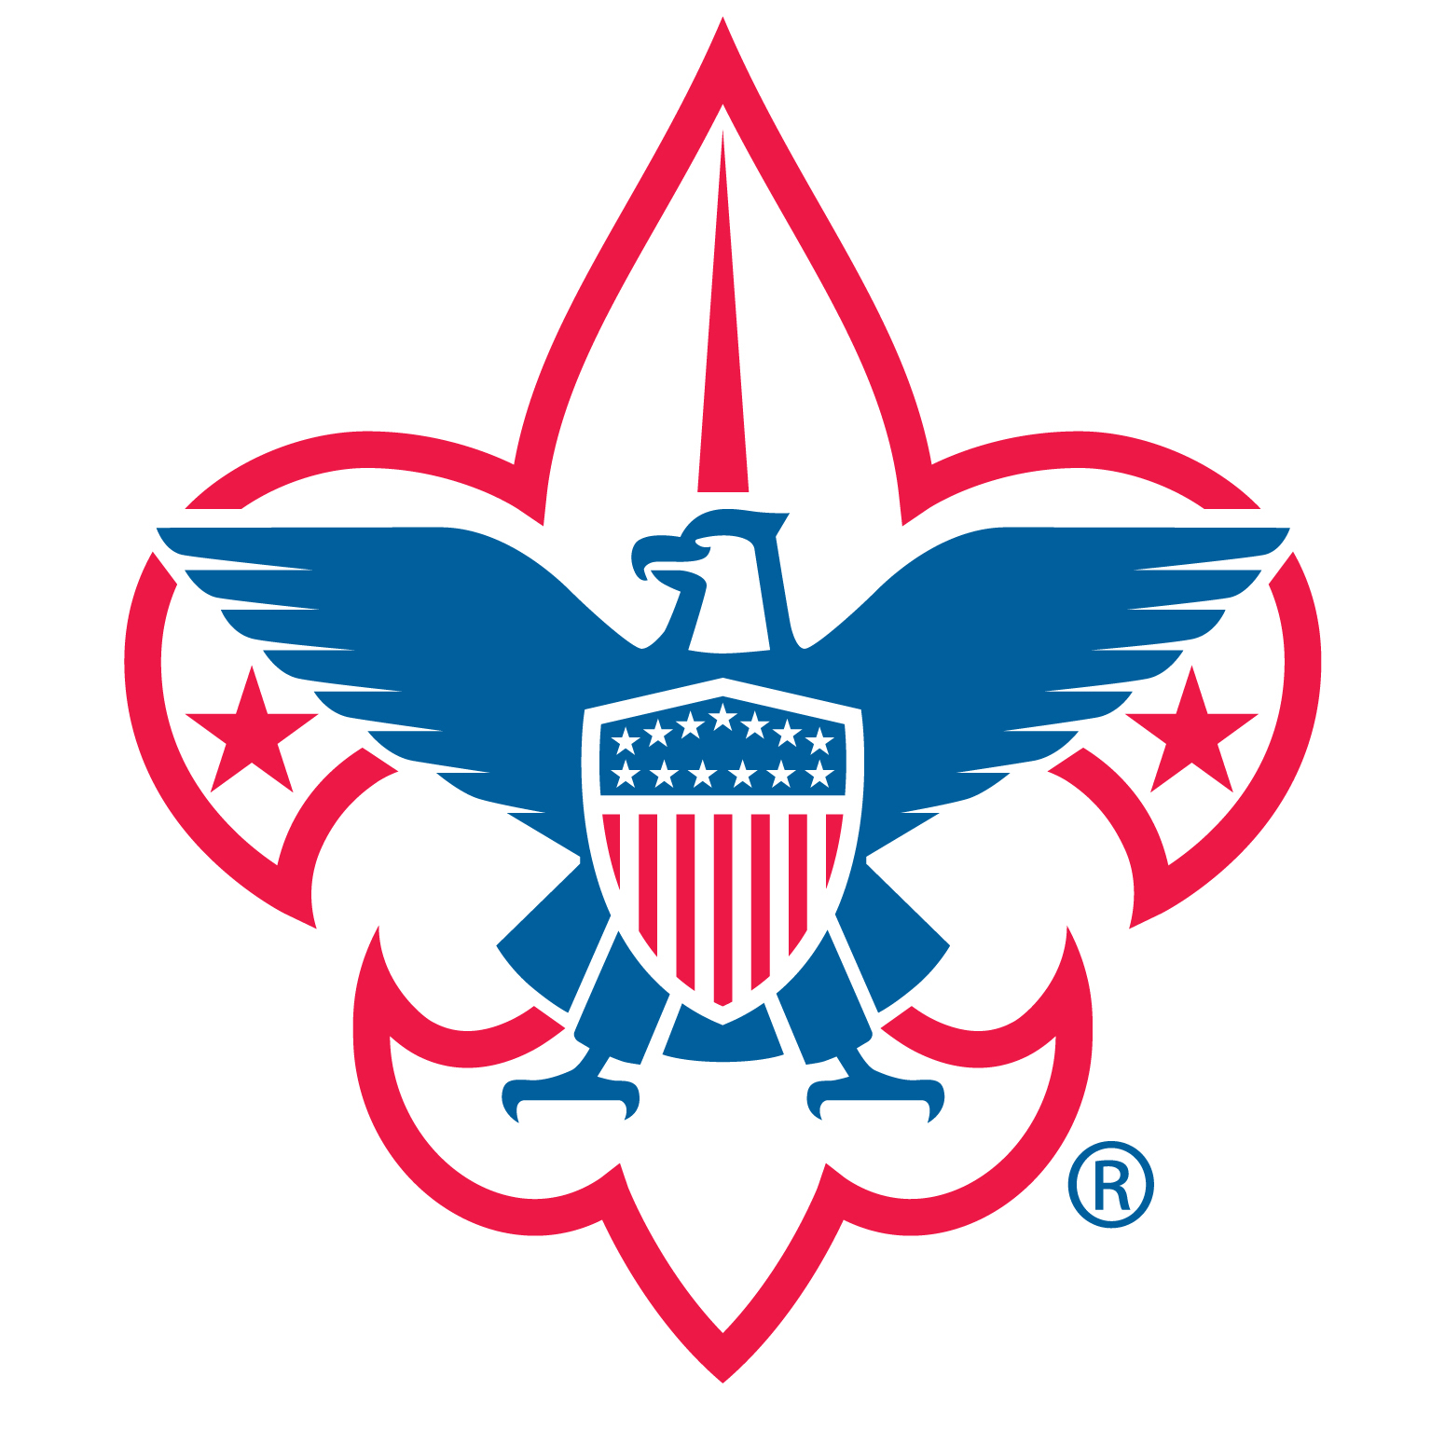

Circle Ten Council
Boy Scouts of America

TROOP 229 ACTIVITIES

To fully participate in Troop 229’s program, your new scout will want to attend:

Troop and Patrol Meetings

Regular meetings are held at _______________ in _________ on Monday nights from 7:00 to 8:30 pm.

Courts of Honor, held to recognize the boys who have earned advancement in rank, merit badges, etc., are held throughout the year at ______.

A meeting schedule, which indicates all our activities, is published at the beginning of the year and updated as needed throughout the year. Monthly activity updates are published on the Troop website.

Detailed information is on our website: http://www.txtroop229.org or by contacting Scoutmaster Jason Ash, jasonwadeash@gmail.com.

Monthly Camping Trips

Camping trips are planned monthly. Also, pre-campout patrol meetings are held during troop meetings to help in planning activities for an outing.

Day Activities (no camping)

Hikes, lock-ins, rock climbing, or service projects, etc. may take the place of a camping trip depending on weather and participation.

Summer Camp

We attend a week-long summer camp every year. This is an excellent way for new scouts to bond with the older boys, earn merit badges, and have fun!!!

In addition, the Troop plans an annual high adventure trip. This could be any combination of hiking trips, mountain climbing, or other activities offering the scouts an exceptional opportunity to become self-sufficient. These trips are for experienced Scouts age 14 and over.

Additional information is available throughout the Scout year.

Training Program

The new scout will be given opportunities at Troop meetings and outings to learn skills and ideals to enable successful camping and life experiences. The campouts will begin the Scout on his advancement program to become an Eagle Scout.

The Scoutmaster and Assistant Scoutmasters work with the boys to guide them through rank advancement. We work on rank advancement on outings and at troop meetings.

TROOP 229 POLICIES

Fees

Dues of $____ are due every month. The fee, along with fund raisers, covers most of the normal costs (merit badges, fees, Court of Honors and other troop expenses) associated with running the troop for the year.

The Boys Life magazine (subscription fee $12.00) is recommended. This is not included in the dues.

The $15.00 BSA yearly registration fee for Scouts and Adults is due in January for the upcoming year. The Troop collects this fee from scouts and active parents and pays it to the Boy Scouts of America. All adults who are associated with our troop must register as Adult Volunteers with BSA. This fee covers BSA insurance and an adult background check. Registered adults will also be required to attend a 1 hour Youth Protection Training class that is valid for 2 years from date of completion.

Scouts behind on dues will not be eligible to receive rank advancement and will not be allowed to attend monthly outings.

Exceptions and assistance is offered to scouts in need. Please contact the Scoutmaster or Committee Chairman to discuss options.

Costs for other activities (campouts, etc.) are separate from the dues and are payable by the participants.

Attendance

Meetings:
A Scouts regular attendance at weekly troop meetings, monthly outings and the troop activities is necessary to fulfill advancement requirements toward the Scouts next rank.

Other Events:
Attendance at campouts, service projects, fund raisers, etc. will be considered in appraising the scout for “Be active in your Troop” and “Scout Spirit” requirements for advancement.

CODE OF CONDUCT:
Scouting is a safe environment, where a boy can feel comfortable trying new experiences. However, there are expectations on how a Scout should act both at meetings and outings. Bullying and or hazing by other scouts or scout adults will NOT be tolerated. Refer to the Code of Conduct for specific behavior expectations and consequences.

PARENT AND THE NEW SCOUT

These are some of the things that will help your child get the most out of Scouting:

- Help your new scout learn to plan ahead; scout activities will have minimal conflict with school work. We realize that school work must come first.
- Help your new scout learn the scout skills and help the scout plan opportunities to master scout skills. The Troop leaders will sign a scout’s book when a skill is learned. See the Boy Scout Handbook for details.
- Encouragement from you can be very helpful in making steady progress in advancement.
- Join your scout on Troop campouts. Parents are welcomed on campouts. You’ll be surprised! You can have a good time on outings too!
- Attend the Courts of Honor which are held throughout the year to honor the boys who have advanced in rank or earned merit badges.
- Serve our Troop as an adult leader. This can be as an Assistant Scoutmaster, committee member, or merit badge counselor. Please contact the Committee Chairman or Scoutmaster for more information.
- Support Troop fund raising programs. Each year, the Troop spends money for equipment, awards, campground fees, and adult and boy leadership training programs. We count on the Scout’s parents to support our fund-raising efforts.
- Provide your new scout with the basic scouting equipment needed for meetings and campouts.
- And most of all, support the ideals and purposes of scouting. In addition to providing fun activities for scouts, the purpose of scouting is to build character, citizenship, and physical and mental fitness. Your scout will get as much out of scouting as he puts into it. Our experience and the National BSA experience shows that he will derive much more from scouting if you, as parents, are involved in the program.

REQUIRED EQUIPMENT FOR THE NEW SCOUT

There are two “Must Have” items for the new scout:
- The OFFICIAL BOY SCOUT HANDBOOK, latest edition.
- The OFFICIAL BOY SCOUT UNIFORM.

The uniform, as worn by the scouts of Troop 229 is required.

The scout will be considered out of uniform if he is not wearing the uniform properly, unless told otherwise by the Troop Scoutmaster.

Class A Uniform

Required:
- Long or short sleeve shirt, official BSA American Flag (right sleeve)
- Pair of green shoulder applets
- Council Patch (left sleeve)
- Emblems of office Troop 229 Patch (left sleeve)
- Rank patch, Patrol patch, Neckerchief and slide
Note: most scouts have the short sleeve shirt

Optional: (required for 1st class and above)
- Pants, long or short, official BSA
- Socks, green, official BSA
- Web belt and buckle, official BSA
See the Scout Handbook for exact placement of emblems.

Class B Uniform

Any scout related T-Shirt.

Except for the Troop 229 patch, all the above items are available at the store in the Scout office: Fairview Office at 5600 US Hwy 75, Fairview, TX, 75069, (972) 359-9992 or the Dallas Office at 8605 Harry Hines Blvd, Dallas, TX, 75235.

Rank emblems are presented at a Court of Honor ceremony by the Advancement Chairperson. The neckerchief slide may either be purchased, or handcrafted, as the scout desires.

If the scout has passed through the Webelos program, he may wear the Arrow of Light emblem and the religious knot. These are available through the Scout office.

Uniforms are required for all regular meetings and District Camporees. Uniforms are worn while traveling on Troop campouts and during flag ceremonies. Uniforms are required at summer camp, preferably short sleeve shirts.

BASIC CAMPING EQUIPMENT FOR THE NEW SCOUT

For an overnight campout and for summer camp the scout will need the following equipment (don’t buy anything until after your 1st troop meeting)

Backpack Mess kit / eating utensils
Liquid filled compass Canteen / Water bottle
Hiking boots Waterproof match case
Rain gear Sleeping Bag / Foam Pad
Personal first aid kit Pocket knife (need TOTIN’ CHIP)
Flashlight (with fresh batteries) Tent

Most other items are furnished by the Troop, such as:

Griddles Dining Fly
Water Jugs Plastic ground cloths
Dutch Ovens Cook Kits
Stoves Patrol Cook Boxes
Saw and Ax

The Troop also maintains a well-stocked first aid kit.

CAMPING EQUIPMENT NOT TO BUY … OR WHAT NOT TO BRING

- Sheath knives of any type are not allowed by the BSA. All knives must be lock-blade. Once a Scout completes his TOTIN’ CHIP, he can carry a knife.
- Axes of any type are not needed. The proper use of the ax is taught to all scouts by out troop leaders using troop axes.
- No liquid fuel warmers or any other devices which use liquid fuel are allowed.
- Candles or any other flame lights are not allowed in tents.
- No aerosol cans (insect repellents, deodorant, etc.). They can explode in campfires!
- No camouflage clothing (jackets, pants, etc.) is allowed. It makes it very difficult to find a lost or hurt scout in the woods.
- NO ELECTRONICS … Adult leaders only may have cell phones in case of an emergency or need to be contacted by a parent.

PARENT PARTICIPATION

Troop committee: The role of the troop committee is to support the Scoutmaster and the troop in an advisory capacity. The committee helps to generate ideas, manage finances, coordinate activities with the sponsoring organization, and provide logistical support, such as coordinating camping trips, special events, etc. for the troop’s scouting program.

Merit badge/skill award instructors: One of the purposes of scouting is to have the boys advance in rank by earning merit badges and completing skill requirements. Any parents with a skill who can advise the boys, organize the activity, or teach the skill can be an advisor. A merit badge counselor is registered with the Boy Scouts of America and is available for counseling and approving the boy for earning the badge. Any adult can be a merit badge counselor. Having adults associated with our troop as counselors makes it easier for the boys to earn merit badges. There are many merit badges in just about every field. We always need more merit badge counselors.

Patrol advisors: The troop is organized into small groups called patrols. Activities on troop meeting nights and on special events revolve around the patrol. The patrol advisor will be an adult; the patrol leader can turn to for help in organizing activities, generating ideas, etc.

Special Events Coordinator: There are many kinds of special events, ranging from service projects to camping trips to fundraising. The coordinator’s function is to put the proper plans in place to ensure that the special event is a success. This type of activity is ideal for the parent(s) who want to help the troop, but cannot do so on a regular basis.

Camping: On camping outings, there is always room for parents to accompany their scout. Registered leaders welcome parental participation to assist in overseeing their boy(s) and experience what scouting is all about. The campouts are always a lot of fun, so please consider participation!

Drivers: Drivers are always needed for campouts, field trips, meetings away from ________, summer camp, etc. Fairly painless, but always appreciated. (Requires YPT).

Idea Generator: Any good idea for an activity will be welcomed, whatever the source. These ideas may range from suggesting an interesting tour to take (place of work, historical walking tour, etc.) to new or different approaches to fundraising, to good suggestions for camping trips.

Circle Ten Council
Making our country better, one man at a time.

Scout Oath
On my honor I will do my best,
To do my duty to God and my country,
And to obey the Scout Law;
To help other people at all times;
To keep myself physically strong,
Mentally awake, and morally straight.

Scout Law
A scout is:
Trustworthy, Loyal, Helpful, Friendly, Courteous, Kind, Obedient, Cheerful, Thrifty, Brave, Clean, Reverant

Scout Motto
Be prepared…..

Vision Statement

The Boy Scouts of America is the nation’s foremost youth program of character development and values-based leadership training.

In the future Scouting will continue to
- Offer young people responsible fun and adventure
- Instill in young people lifetime values and develop in them ethical character as expressed in the Scout Oath and Law.
- Train young people in citizenship, service, and leadership.
- Save America’s communities and families with its quality, values-based program.

